* Copyright for test papers and marking guides remains with *West Australian Test Papers*.
* The papers may only be reproduced within the purchasing school according to the advertised conditions of sale.
* Test papers must be withdrawn after use and stored securely in the school until Friday, December 2

**HUMAN BIOLOGY**

**Unit 1 & 2**

**2016**



Name: _______________________________________________________

Teacher: ___________________________________________________

***TIME ALLOWED FOR THIS PAPER***

Reading time before commencing work: Ten minutes

Working time for the paper: Three hours

***MATERIALS REQUIRED/RECOMMENDED FOR THIS PAPER***

**To be provided by the supervisor:**

* This Question/Answer Booklet
* Multiple Choice Answer Sheet

**To be provided by the candidate:**

* Standard items: Pens, pencils, eraser or correction fluid, ruler, highlighter, ruler.
* Special items: Calculators satisfying the conditions set by the Schools

Curriculum and standards authority for this subject.

***IMPORTANT NOTE TO CANDIDATES***

* No other items may be taken into the examination room. It is **your** responsibility to ensure that you do not have any unauthorised notes or other items of a non-personal nature in the examination room. If you have any unauthorised material with you, hand it to the supervisor **before** reading any further.

***Structure of this paper***

|  |  |  |  |  |  |
| --- | --- | --- | --- | --- | --- |
| Section | Suggested working time | Number of questions available | Number of questions to be attempted | Marks | Percentage |
| SECTION ONE:  Multiple-choice | 40 minutes | 30 | All | 30 | 30 |
| SECTION TWO:  Short answers | 100 minutes | 10 | All | 100 | 50 |
| SECTION THREE:  Extended answers | 40 minutes | 3 | 2 | 40 | 20 |
|  |  |  | Total marks | 170 | 100 |

**Instructions to candidates**

1. The rules for the conduct of Western Australian external examinations are detailed in the *Year 12 Information Handbook 2016.* Sitting this examination implies that you agree to abide by these rules.

2. Answer the questions according to the following instructions.

Section One: Answer all questions on the separate Multiple-choice Answer Sheet provided. For each question shade the box to indicate your answer. Use only a blue or black pen to shade the boxes. If you make a mistake, place a cross through that square, do not erase or use correction fluid, and shade your new answer. Marks will not be deducted for incorrect answers. No marks will be given if more than one answer is completed for any question.

Sections Two and Three: Write your answers in this Question/Answer Booklet.

3. You must be careful to confine your responses to the specific questions asked and to follow any instructions that are specific to a particular question.

4. Spare pages are included at the end of this booklet. They can be used for planning your responses and/or as additional space if required to continue an answer.

* Planning: If you use the spare pages for planning, indicate this clearly at the top of the page.
* Continuing an answer: If you need to use the space to continue an answer, indicate in the original answer space where the answer is continued, i.e. give the page number. Fill in the number of the question(s) that you are continuing to answer at the top of the page.

**Section One: Multiple-choice 30% (30 Marks)**

This section has **30** questions. Answer **all** questions on the separate Multiple-choice Answer Sheet provided. For each question shade the box to indicate your answer. Use only a **blue or black pen** to shade the boxes. If you make a mistake, place a cross through that square, do not erase or use correction fluid, and shade your new answer. Marks will not be deducted for incorrect answers. No marks will be given if more than one answer is completed for any question.

Suggested working time: **40 minutes**.

________________________________________________________________________

1. All cells in the human body contain the hereditary material which is isolated from the rest of the cell by

(a) cell membrane

(b) nuclear envelope

(c) nucleoplasm

(d) nucleolus

1. What kind of inheritance is represented by the following pedigree chart?

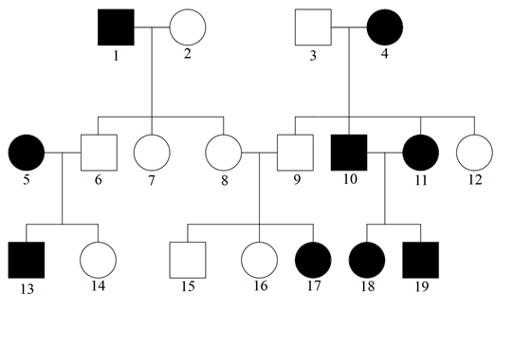

1. sex-linked
2. co-dominant
3. autosomal recessive
4. autosomal dominant
5. Which of the following is NOT a function of the liver?
6. formation of glycogen
7. formation of urea
8. production of bile
9. secretion of digestive enzymes
10. Which of the following does NOT use ATP (adenosine triphosphate)?
11. diffusion of oxygen across the alveolar surface
12. maintenance of a constant body temperature
13. passage of nerve impulses
14. active transport of glucose into the villi
15. Which of the following describe changes that occurs when a person inhales?

**Diaphragm External intercostal muscles**

1. contracts contract
2. contracts no change
3. contracts relax
4. relaxes contract
5. Research shows a 68% decrease of spina bifida rates and other neural tube defects in Aboriginal children since mandatory fortification of wheat-flour for bread was introduced in Australia in 2009. Which vitamin was supplemented in the bread?

*(Newspaper source: The West Australian 17 December 2015, page 62).*

1. ascorbic acid
2. thiamine
3. folate
4. niacin
5. About 170 litres of fluid are filtered by the kidneys every day. Only 1.5 litres are excreted in the urine. What happens to the remaining 168.5 litres?
6. It is lost in the perspiration as sweat.
7. It becomes tissue fluid.
8. It is stored in the urinary bladder.
9. It is reabsorbed into the blood.
10. Which of the following correctly identifies where different types of cartilage are located in the human body?

|  |  |  |  |
| --- | --- | --- | --- |
|  | **Hyaline cartilage** | **Elastic cartilage** | **Fibrocartilage** |
| (a) | bronchi | intervertebral discs | larynx |
| (b) | intervertebral discs | bronchi | external ear pinna |
| (c) | trachea | external ear pinna | intervertebral discs |
| (d) | external ear pinna | trachea | bronchi |

1. When a soldier salutes to his superior, the movement of his lower arm may be described as
2. extension.
3. flexion.
4. bending.
5. straightening.
6. There are different types of birth control methods – hormonal, surgical or mechanical.

Identify the correct match for each method.

|  |  |  |  |
| --- | --- | --- | --- |
|  | **hormonal** | **mechanical** | **surgical** |
| (a) | condom | spermicide | intrauterine device |
| (b) | emergency contraceptive pill | intrauterine device | vasectomy |
| (c) | vasectomy | diaphragm | tubal ligation |
| (d) | intrauterine device | condom | emergency contraceptive pill |

Refer to the following diagram to answer Question 14 and 15.

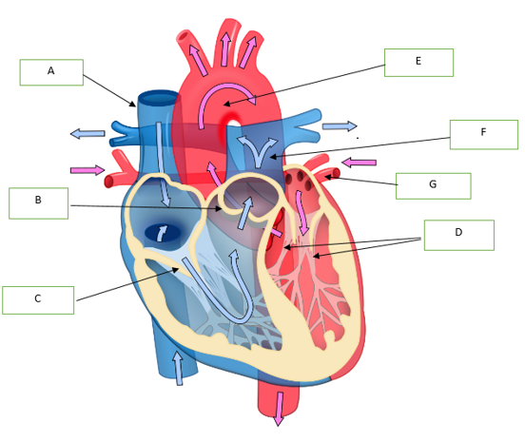

1. The parts of the heart labelled B and D are _______ and ________ respectively.
2. semi-lunar valves, chordae tendineae
3. chordae tendineae, semi-lunar valves
4. aorta, left ventricle
5. septum valves, atrioventricular valves
6. Oxygenated blood flows into and out of the heart is described by the pathway
7. A & B → right atrium → right ventricle → F
8. A & B → left atrium → left ventricle → F
9. G → left atrium → left ventricle → E
10. G → right atrium → right ventricle → E
11. Which of the following sexually transmitted diseases can be easily treated with antibiotics?
12. herpes simplex
13. genital warts
14. chlamydia trachomatis
15. scabies
16. The following diagram shows the changes in the thickness of the uterine lining of a woman during a menstrual cycle. On what day would the woman be most fertile?

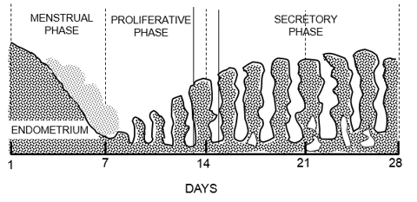

1. Day 7
2. Day 14
3. Day 21
4. Day 28

1. The diagram below shows the arrangement of blood vessels in the uterus wall and

placenta of a pregnant woman. As blood flows from 1 to 2, the level of _____________

will increase.

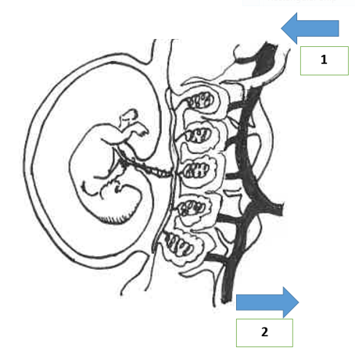

1. carbon dioxide
2. glucose
3. amino acids
4. oxygen
5. At which phase of cell division can we observe the following diagram?

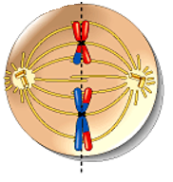

1. Metaphase 1 of meiosis
2. Metaphase 2 of meiosis
3. Anaphase 1 of mitosis
4. Anaphase 2 of meiosis
5. The dominant hormone controlling the secretory phase of the menstrual cycle is
6. progesterone.
7. follicle-stimulating hormone.
8. luteinizing hormone.
9. human chorionic gonadotropin (HCG).
10. The diagram shows a fetus at a stage of pregnancy where the hormonal system plays an important role in initiating it. Which of the following correctly indicate the main hormone(s) at work?

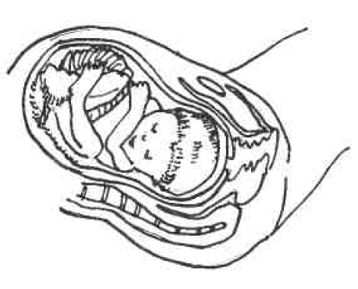

1. oestrogen and oxytocin
2. progesterone and oestrogen
3. oestrogen
4. oxytocin

Refer to the following table for Question 22 and 23.

The table shows the amino acid and the corresponding mRNA codons.

**mRNA codons for 6 amino acids**

|  |  |
| --- | --- |
| **Amino acid** | **Codon** |
| alanine | GCA |
| leucine | UUG |
| methionine | AUG |
| arginine | CGU |
| histidine | CAU |
| tyrosine | UAC |

1. What is the base sequence on a DNA molecule that will allow the amino acid arginine to be incorporated into the polypeptide chain?
2. GCT
3. CGU
4. CGA
5. GCA
6. Transfer RNA has a role in the translation of polypeptides. What amino acid would be carried to the ribosome by transfer RNA with the anti-codon CGU?
7. arginine
8. alanine
9. histidine
10. methionine
11. Research with embryonic stem cells presents ethical issues because one needs to consider
12. the advantages and disadvantages of using the embryonic stem cells.
13. how society can fully benefit from the use of embryonic stem cells.
14. the moral status of the human embryo.
15. the potential commercial benefit and sources of funding for embryo research.
16. Colostrum are important for the health of a very new baby mainly because it contains
17. nutrients.
18. amino acids.
19. vitamins.
20. antibodies.

Please refer to the following graph to answer Question 26.

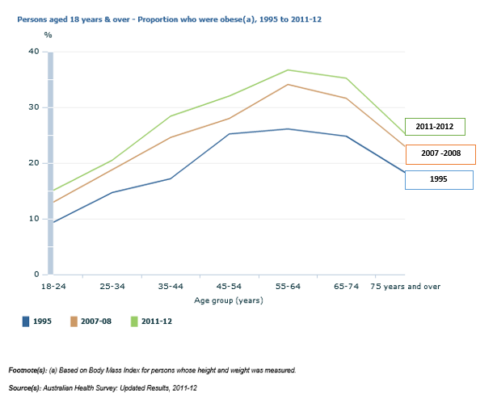

1. What is the most likely conclusion that can be drawn from this graph?
2. There is a positive correlation between age and the percentage of persons who are obese.
3. Older persons develop higher body mass index and are at greater risk of obesity.
4. The increase in the proportion of people who are overweight or obese is being driven by a general increase in weight and body mass index over time.
5. It is not possible to draw any conclusion.

27. An example of a gliding joint is the

1. Inter-carpal joint.
2. radiocarpal joint.
3. intervertebral joint.
4. phalangeal joint.

29. A cell in the germinal epithelium of the seminiferous tubules has 12 units of DNA. Which of the following indicate the correct number of units of DNA in a primary spermatocyte, a secondary spermatocyte and a spermatid?

|  |  |  |  |
| --- | --- | --- | --- |
|  | **a primary spermatocyte** | **a secondary spermatocyte** | **a spermatid** |
| (a) | 12 | 6 | 6 |
| (b) | 24 | 12 | 6 |
| (c) | 12 | 6 | 3 |
| (d) | 12 | 12 | 12 |

30. In the placenta, the mother’s blood and the fetal blood flows in opposite directions.

This is important because this counter current flow will

1. increase surface area for nutrient absorption.
2. increase the rate of waste removal.
3. build up concentration gradient all the way along the capillary to facilitate diffusion.
4. balance the input of nutrients and output of waste products.

**End of Section One**

**Section Two: Short answer 50% (100 Marks)**

This section has **ten (10)** questions. Answer **all** questions. Write your answers in the spaces provided.

Spare pages are included at the end of this booklet. They can be used for planning your responses and/or as additional space if required to continue an answer.

* + Planning: If you use the spare pages for planning, indicate this clearly at the top of the page.
  + Continuing an answer: If you need to use the space to continue an answer, indicate in the original answer space where the answer is continued, i.e. give the page number. Fill in the number of the question(s) that you are continuing to answer at the top of the page.

Suggested working time: **100 minutes**.

**Question 33 (12 marks)**

1. How is the composition of blood different from lymph? (1 mark)

________________________________________________________________

________________________________________________________________

1. Complete the table to show correct antigens and antibodies for each blood group. (4 marks)

|  |  |  |
| --- | --- | --- |
| **Blood Group** | **Antigens on red blood cells** | **Antibodies in plasma** |
| A | Antigen A |  |
| B |  | Anti-A |
|  | Antigen A and Antigen B | Neither anti-A nor anti-B |
|  | Neither antigen A nor antigen B | Both anti-A and anti-B |

1. Use an example to explain why it is important to match the blood groups of the donor and recipient during blood transfusions. (2 marks)

***________________________________________________________________***

***________________________________________________________________***

i) What makes a cardiac cycle? (1 mark)

***_________________________________________________________________***

ii) At the peak of a triathlon, James’ cardiac output was monitored to be 17.5

L/min. Define cardiac output and explain what the numerical value stands for.

(2 marks)

__________________________________________________________________

__________________________________________________________________

1. Outline two changes that occur to the fetal circulation after birth. (2 marks)

__________________________________________________________________

__________________________________________________________________

___________________________________________________________________

**Question 34 (8 marks)**

Refer to the diagram below to answer Question 34.

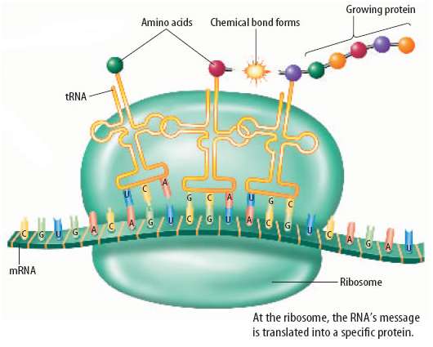

**Process Q**

1. Identify the process Q as depicted in the diagram above. (1 mark)

***______________________________***

1. Outline the steps involved in process Q to form the end-product.

(4 marks)

__________________________________________________________

__________________________________________________________

__________________________________________________________

__________________________________________________________

1. Give three examples of the end products and their role in cellular functions. (3 marks)

__________________________________________________________

__________________________________________________________

__________________________________________________________

**Question 35 (10 marks)**

1. A student wrote in an exam ` Homologous chromosomes are the same as each other because they have the same genes’. Explain what is wrong with this statement. (2 marks)

__________________________________________________________________

__________________________________________________________________

1. A pair of chromatids form the chromosome. Explain whether you agree or disagree with this statement. (2 marks)

***__________________________________________________________________***

***__________________________________________________________________***

1. State the purpose of the following types of cell division. (2 marks)
2. mitosis – _______________________________________________
3. meiosis – ______________________________________________
4. What are the differences between the cell divisions involved in spermatogenesis and oogenesis? (4 marks)

________________________________________________________________

________________________________________________________________

________________________________________________________________

________________________________________________________________

**Question 36 (8 marks)**

1. What is meant by epigenetics? (1 mark)

***__________________________________________________________________***

Refer to the diagram below to answer part (b) – (d).

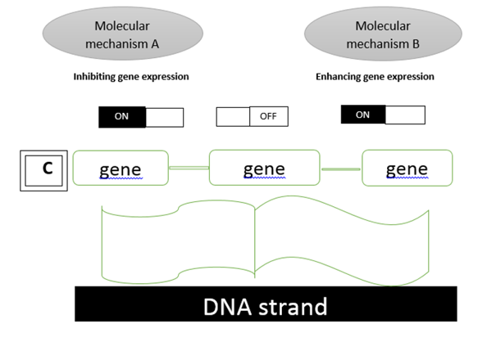

1. Identify the molecular mechanisms as follows: (2 marks)
2. A – ***___________________________***
3. B –  ***___________________________***

(iii) Cinteracts with DNA and changes the level of gene expression in a cell.

C is known as ____________________. (1 mark)

1. Using your understanding of epigenetics, explain why identical twins are preferred subjects for research rather than fraternal twins and why twins chosen for study cover a large span of ages. (2 marks)

__________________________________________________________________

__________________________________________________________________

1. How is epigenetic inheritance different from genetic inheritance? (2 marks)

­­­­­­­­­­­­­­­­­­­­______________________________________________________________________________________

______________________________________________________________________________________

**Question 37 (10 marks)**

Please refer to the diagram to answer Question 37.

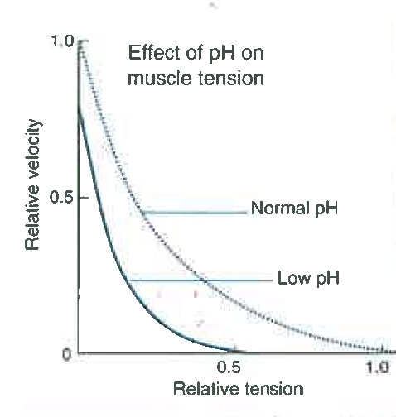

1. What type of respiration is taking place when oxygen demands exceeds supply as shown in the diagram above? (1 mark)

***______________________________________________________________***

1. What happens in the muscle that causes a fall in the tissue pH? (1 mark)

***_______________________________________________________________***

1. Why does this occurrence in (b) lead to muscle fatigue? (1 mark)

***_________________________________________________________________***

1. State the relationship between tissue pH and muscle tension as indicated in the graph. (1 mark)

***__________________________________________________________________***

1. Explain why the reason for fatigue in a marathon runner is different from a 100 m sprinter. (1 mark)

***_________________________________________________________________***

1. Using diagram(s), outline how the sliding filament model can be used to explain muscle contraction. (5 marks)

**Question 38 (10 marks)**

The following diagram shows the respiratory system in a human body.

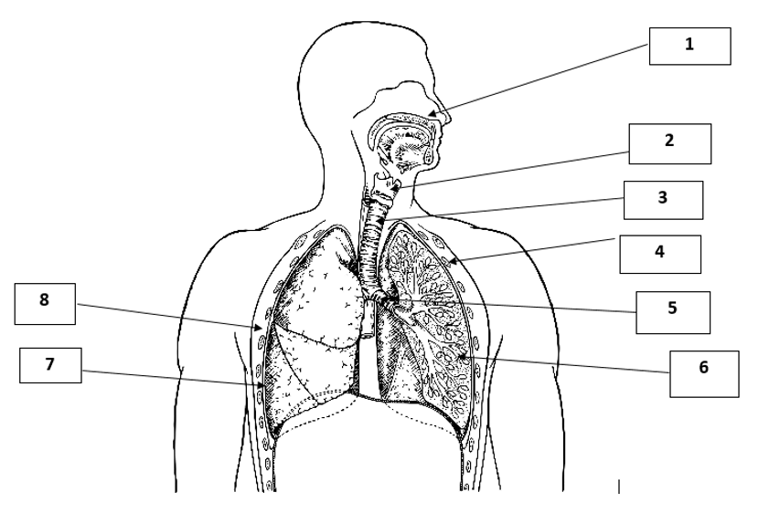

1. Label the numbered structures 2, 5, 6 and 7. (4 marks)

|  |  |
| --- | --- |
| 2 |  |
| 5 |  |
| 6 |  |
| 7 |  |

1. Select two structures of the respiratory system and state how each of these structures is suited to the process of gaseous exchange. (4 marks)

__________________________________________________________________

___________________________________________________________________

___________________________________________________________________

___________________________________________________________________

1. Explain how a person with a collapsed lung can still function fairly normally.

(2 marks)

__________________________________________________________________

__________________________________________________________________

**Question 39 (8 marks)**

The ability to discriminate between the colours red and green is controlled by a gene located in the X chromosome. Individuals who are unable to distinguish between the two colours possess the recessive allele of this gene.

1. Why would colour blindness be more common in males than in females? (1 mark)

_________________________________________________________________

1. An unaffected woman who carries a recessive allele is considered to be heterozygous. What term can be used to describe a colour blind man?

(1 mark)

***__________________________________________________________________***

1. Describe a scenario where a couple produce daughters who all have normal vision and sons who are all colour blind. Use a punnett square to illustrate this, describing the genotypes of both parents and their children. (3 marks)
2. (i) Explain why we inherit nuclear DNA from both our parents but mitochondrial

DNA from our mothers. (1 mark)

__________________________________________________________________

__________________________________________________________________

(ii) For what reasons would the study of mitochondrial DNA be extremely useful?

Explain why this would be the case. (2 marks)

__________________________________________________________________

***__________________________________________________________________***

**End of Section Two**

**Section Three: Extended answer 20% (40 Marks)**

This section contains **three (3)** questions. You must answer **two (2)** questions.

Make sure you clearly indicate which question you are answering and write your answers in the space provided.

Spare pages are included at the end of this booklet. They can be used for planning your responses and/or as additional space if required to continue an answer.

* + Planning: If you use the spare pages for planning, indicate this clearly at the top of the page.
  + Continuing an answer: If you need to use more space to continue an answer, indicate in the original answer space where the answer is continued, i.e. give the page number. Write the number of the question(s) that you are continuing to answer at the top of the additional space page.

Responses could include clearly labeled diagrams with explanatory notes; lists of points with linking sentences; clearly labeled tables and graphs; and annotated flow diagrams with introductory notes.

Suggested working time: **40 minutes**.

**Question 41 (20 marks)**

1. Describe how genetic variation occurs during the process of meiosis and indicate how non-disjunction can occur. Include in your answer a description of the outcome of non-disjunction. (4 marks)

1. Compare and contrast two named types of chromosomal analysis techniques that can be performed on a fetus to detect the genetic condition caused by non-disjunction. Identify the risks involved, state the limitations of each technique and specify other disorders that can also be detected through these techniques.

(12 marks)

1. Discuss two ethical considerations in the use of assisted reproductive technologies.

(4 marks)

**Question 42 (20 marks)**

The human body performs a number of important functions on the molecular as well as systemic level to ensure waste products are effectively removed from the body.

1. Describe how carbon dioxide is transported away from the body cells to the exterior. (10 marks)
2. Using an annotated diagram, describe how water needed by the body is reabsorbed; and how named metabolic (organic) wastes and excess water are transported from the body cells to be discharged to the exterior. (10 marks)

**Question 43 (20 marks)**

1. Describe the changes involved from the formation of the zygote to its implantation in the uterine wall of the mother. You may use diagrams to support your answer.

(9 marks)

1. Identify some environmental factors that can affect the development of the fetus.

Use an example to illustrate how the environmental factor you have stated can

affect the development of the fetus. (5 marks)

END OF SECTION THREE

Question number: ________________

________________________________________________________________________________________________________________________________________________________________________________________________________________________________________________________________________________________________________________________________________________________________________________________________________________________________________________

________________________________________________________________________________________________________________________________________________________________________________________________________________________________________________________________________________________________________________________________________________________________________________________________________________________________________________

________________________________________________________________________________________________________________________________________________________________________________________________________________________________________________________________________________________________________________________________________________________________________________________________________________________________________________

________________________________________________________________________________________________________________________________________________________________________________________________________________________________________________________________________________________________________________________________________________________________________________________________________________________________________________

________________________________________________________________________________________________________________________________________________________________________________________________________________________________________________________________________________________________________________________________________________________________________________________________________________________________________________________________________________________________________________________________________________________________________________________________________________________________________________________________________________________________________________________________________________

Question number: ________________

________________________________________________________________________________________________________________________________________________________________________________________________________________________________________________________________________________________________________________________________________________________________________________________________________________________________________________________________________________________________________________________

________________________________________________________________________________________________________________________________________________________________________________________________________________________________________________________________________________________________________________________________________________________________________________________________________________________________________________

________________________________________________________________________________________________________________________________________________________________________________________________________________________________________________________________________________________________________________________________________________________________________________________________________________________________________________

________________________________________________________________________________________________________________________________________________________________________________________________________________________________________________________________________________________________________________________________________________________________________________________________________________________________________________

________________________________________________________________________________________________________________________________________________________________________________________________________________________________________________________________________________________________________________________________________________________________________________________________________________________________________________________________________________________________________________________________________________________________________________________________________________________________________________________________________

Question number: ________________

________________________________________________________________________________________________________________________________________________

________________________________________________________________________

________________________________________________________________________________________________________________________________________________________________________________________________________________________________________________________________________________________________________________________________________________________________________________________________________________________________________________

________________________________________________________________________________________________________________________________________________________________________________________________________________________________________________________________________________________________________________________________________________________________________________________________________________________________________________

________________________________________________________________________________________________________________________________________________________________________________________________________________________________________________________________________________________________________________________________________________________________________________________________________________________________________________

________________________________________________________________________________________________________________________________________________________________________________________________________________________________________________________________________________________________________________________________________________________________________________________________________________________________________________

________________________________________________________________________________________________________________________________________________________________________________________________________________________________________________________________________________________________________________________________________________________________________________________________________________________________________________________________________________________________________________________

Question number: ________________

________________________________________________________________________________________________________________________________________________________________________________________________________________________

________________________________________________________________________

________________________________________________________________________________________________________________________________________________________________________________________________________________________________________________________________________________________________________________________________________________________________________________________________________________________________________________

________________________________________________________________________________________________________________________________________________________________________________________________________________________________________________________________________________________________________________________________________________________________________________________________________________________________________________

________________________________________________________________________________________________________________________________________________________________________________________________________________________________________________________________________________________________________________________________________________________________________________________________________________________________________________

________________________________________________________________________________________________________________________________________________________________________________________________________________________________________________________________________________________________________________________________________________________________________________________________________________________________________________

________________________________________________________________________________________________________________________________________________________________________________________________________________________________________________________________________________________________________________________________________________________________________________________________________________________________________________

Question number: ________________

________________________________________________________________________________________________________________________________________________________________________________________________________________________________________________________________________________________________

________________________________________________________________________

________________________________________________________________________________________________________________________________________________________________________________________________________________________________________________________________________________________________________________________________________________________________________________________________________________________________________________

________________________________________________________________________________________________________________________________________________________________________________________________________________________________________________________________________________________________________________________________________________________________________________________________________________________________________________

________________________________________________________________________________________________________________________________________________________________________________________________________________________________________________________________________________________________________________________________________________________________________________________________________________________________________________

________________________________________________________________________________________________________________________________________________________________________________________________________________________________________________________________________________________________________________________________________________________________________________________________________________________________________________

________________________________________________________________________________________________________________________________________________________________________________________________________________________________________________________________________________________________________________________________________________________________________

Additional working space

Question number: ________________

________________________________________________________________________________________________________________________________________________________________________________________________________________________________________________________________________________________________________________________________________________________________________

________________________________________________________________________

________________________________________________________________________________________________________________________________________________________________________________________________________________________________________________________________________________________________________________________________________________________________________________________________________________________________________________

________________________________________________________________________________________________________________________________________________________________________________________________________________________________________________________________________________________________________________________________________________________________________________________________________________________________________________

________________________________________________________________________________________________________________________________________________________________________________________________________________________________________________________________________________________________________________________________________________________________________________________________________________________________________________

________________________________________________________________________________________________________________________________________________________________________________________________________________________________________________________________________________________________________________________________________________________________________________________________________________________________________________

________________________________________________________________________________________________________________________________________________________________________________________________________________________

Additional working space

Question number: ________________

________________________________________________________________________________________________________________________________________________________________________________________________________________________________________________________________________________________________________________________________________________________________________________________________________________________________________________________________________________________________________________________

________________________________________________________________________

________________________________________________________________________________________________________________________________________________________________________________________________________________________________________________________________________________________________________________________________________________________________________________________________________________________________________________

________________________________________________________________________________________________________________________________________________________________________________________________________________________________________________________________________________________________________________________________________________________________________________________________________________________________________________

________________________________________________________________________________________________________________________________________________________________________________________________________________________________________________________________________________________________________________________________________________________________________________________________________________________________________________

________________________________________________________________________________________________________________________________________________________________________________________________________________________________________________________________________________________________________________________________________________________________________________________________________________________________________________________________________________________________________________________

Additional working space

Question number: ________________

________________________________________________________________________________________________________________________________________________________________________________________________________________________________________________________________________________________________________________________________________________________________________________________________________________________________________________________________________________________________________________________________________________________________________________________________________________________________________________________________________________________________________________________________________________

________________________________________________________________________

________________________________________________________________________________________________________________________________________________________________________________________________________________________________________________________________________________________________________________________________________________________________________________________________________________________________________________

________________________________________________________________________________________________________________________________________________________________________________________________________________________________________________________________________________________________________________________________________________________________________________________________________________________________________________

________________________________________________________________________________________________________________________________________________________________________________________________________________________________________________________________________________________________________________________________________________________________________________________________________________________________________________

________________________________________________________________________________________________________________________________________________________________________________________________________________________________________________________________________________________________

Additional working space

Spare Grid for Question 40 (a)



References

**Section One**

**Multiple choice question 13 and 14**

Structure of the heart

<https://upload.wikimedia.org/wikipedia/commons/thumb/6/67/Heart_diagram_blood_flow_en.svg/913px-Heart_diagram_blood_flow_en.svg.png>

This file is licensed under the [Creative Commons](https://en.wikipedia.org/wiki/en:Creative_Commons) [Attribution-Share Alike 3.0 Unported](https://creativecommons.org/licenses/by-sa/3.0/deed.en) license

**Multiple choice question 17**

Menstrual cycle diagram adapted from: Harrison, J. (n.d.). *Unit 2B Hormonal control of reproductive system.* Slide no.9. Western Australia: Ecopress Publications.

**Multiple choice question 18**

Drawing provided. Courtesy of S Yap.

**Multiple choice question 21**

Drawing provided. Courtesy of S Yap.

**Multiple choice question 26**

Graph of percentage of persons 18 years & over from 1995 to 2011-2012 – Retrieved on 12 March 2016 from *the Australian Bureau of Statistics 4338.0 – Profiles of Health, Australia 2011-13 released on 7 June 2013 Issue* from

<http://www.abs.gov.au/ausstats/abs@.nsf/Lookup/by%20Subject/4338.0~2011-13~Main%20Features~Overweight%20and%20obesity~10007>

**Section Two**

**Question 31**

Histology Slide A - <http://spice.wa.edu.au>

Histology Slide B - <http://spice.wa.edu.au>

**Question 34**

Translation in Protein Synthesis - <http://www.biologyteksbylauryncarter.weebly.com/protein-synthesis.html>

**Question 36**

Diagram provided. Courtesy of S Yap.

**Question 37**

Graph showing the effect of pH on muscle tension adapted from: Biology Modular Workbook Series. 2nd Ed. (2013) *Anatomy and Physiology*. New Zealand: Biozone International Ltd. Page 79.

**Question 38**

Respiratory system – adapted from [Diagram]. Retrieved March, 10, 2016. [www.shutterstock.com/pic-89315977](http://www.shutterstock.com/pic-89315977)